**Packet Sniffing and Spoofing Lab**

**Karan Amrutesh**

**Task 1.a.** Understanding sniffex:

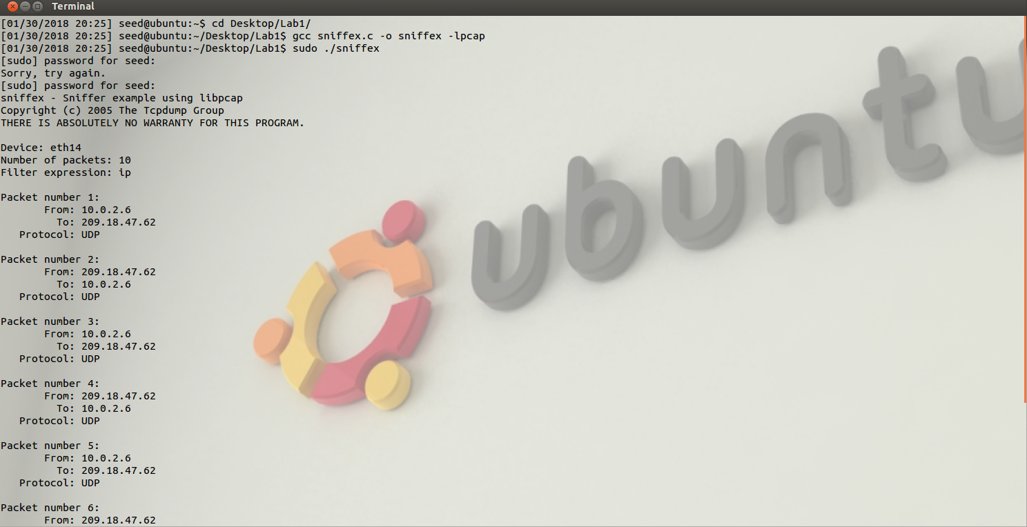

Problem 1 Sequence of library calls is as follows:

1. pcap_lookupdev: We set the device that we want to perform packet sniffing.
2. pcap_lookupnet: Returns the network numbers and the network mask of the capture device.
3. pcap_open_live: Then we open a sniffing session on the capture device. We can set the promisc parameter to true/false depending on whether we want to run it in promiscuous mode or not.
4. pcap_datalink: This routine returns a value indicating the type of link-layer headers.
5. pcap_compile: This compiles the filter expression stored in a regular string in order to set the filter.
6. pcap_setfilter: This applies the compiled filter.
7. Now, we can either use pcap_next to sniff one packet at a time use pcap_loop to sniff *n* number of packets. In this call, we also specify the callback function to examine the packet.
8. pcap_freecode: Frees up the allocated memory generated by pcap_compile.
9. pcap_close: Finally we close the sniffing session.

Problem 2 Why do you need the root privilege to run sniffex? Where does the program fail if executed without the root privilege?

The sniffex needs to access the network interface card. Network interface card is the physical device that accepts the packets into the system and only root can access it.

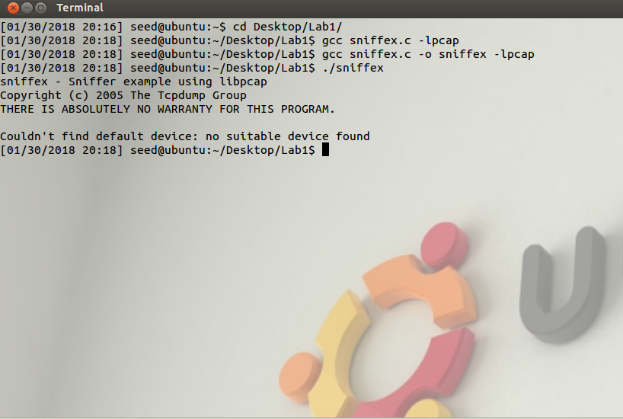

The program fails in the lookupdev call as it is looking for an interface to perform sniffing and this requires root access.

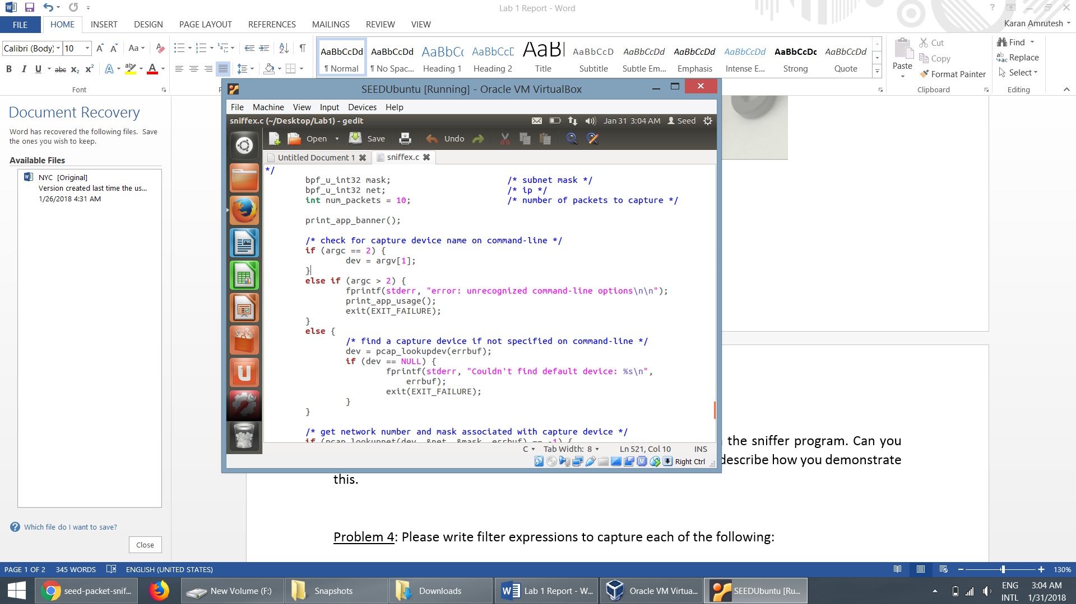

Problem 3 Please turn on and turn off the promiscuous mode in the sniffer program. Can you demonstrate the difference when this mode is on and off? Please describe how you demonstrate this.

* With the *promiscuous mode on*, every frame that is sent in the network is passed on to the kernal by the Network Interface Card irrespective whether they are addressed to it or not.
* We demonstrate by a simple telnet call to some other host. Although the packets are not addressed to (10.0.2.6), they are captured by the sniffer program running in this machine. This is shown in the snapshot below.

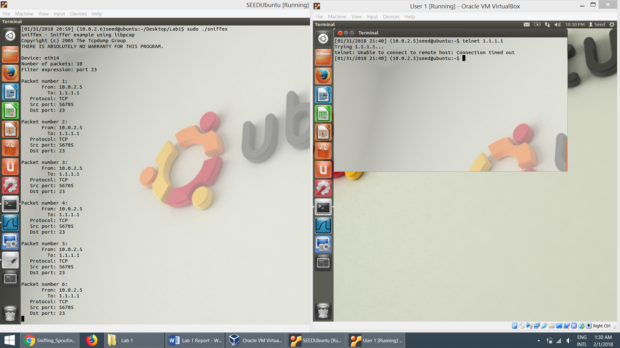

* With the *promicuous mode off*, the NIC passes only those frames to the kernel that are destined to it.
* The snapshot below shows the sniffex program running on (10.0.2.6) is unable to capture the frames sent by (10.0.2.5) to some other host.

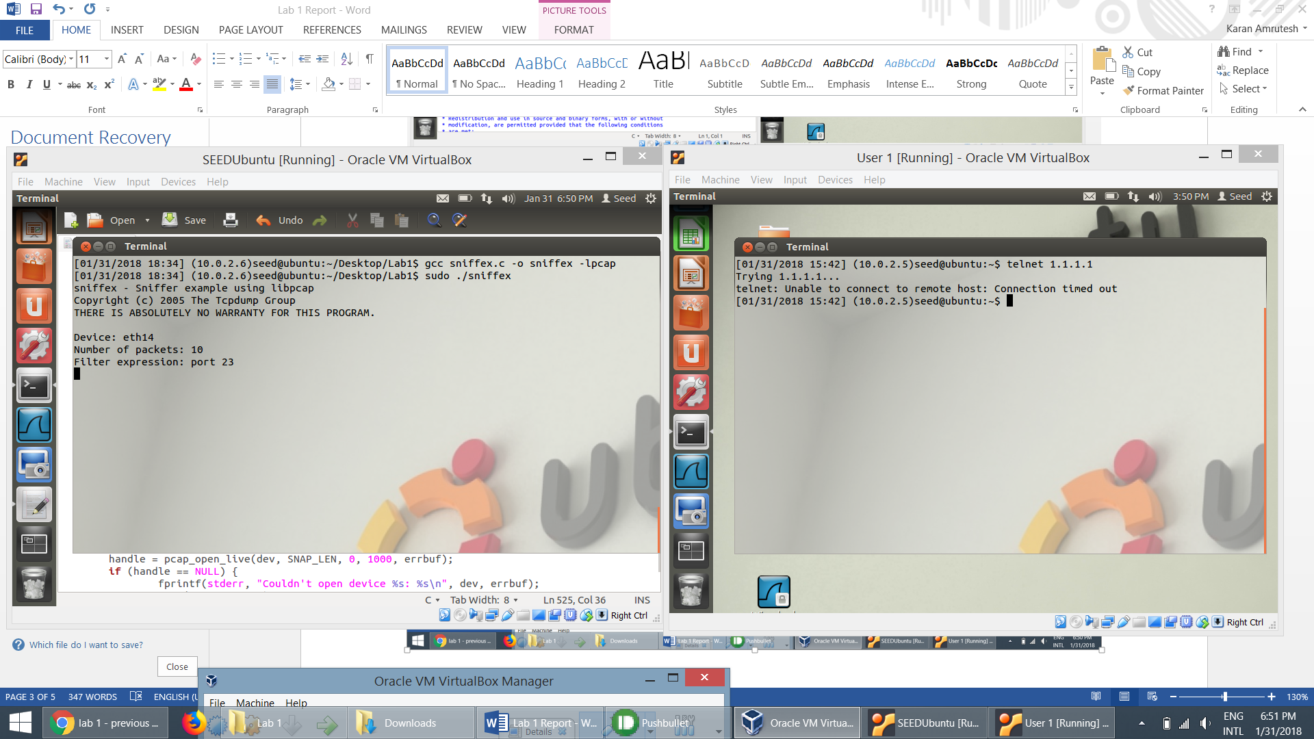

* The snapshot below showsthe sniffex program captures the frames that are destined to it with the promiscuous mode off.

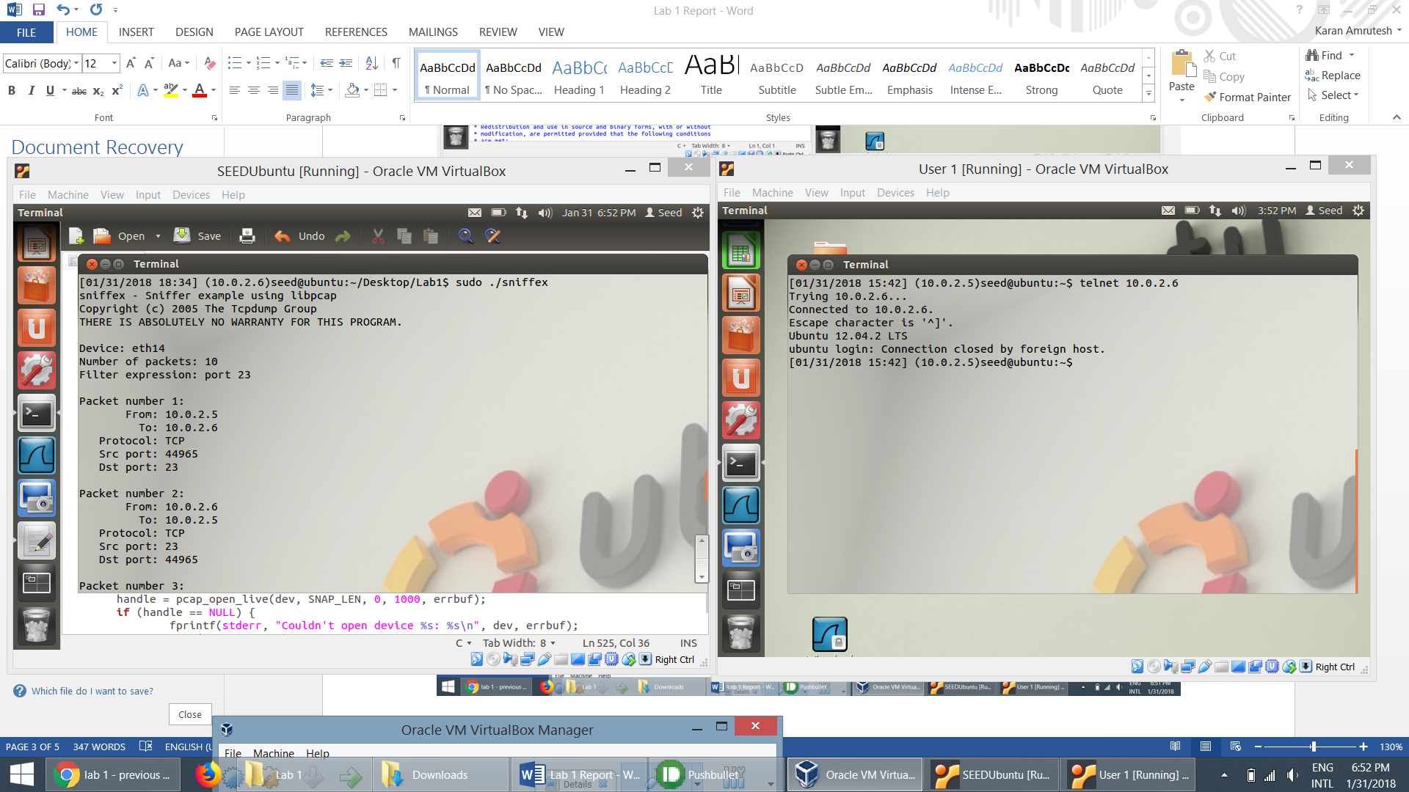

**Task 1.b.** Please write filter expressions to capture each of the following:

* Capture the ICMP packets between two specific hosts

char filter_exp[] = "icmp and ((src 10.0.2.5 and dst 10.0.2.7) or (src 10.0.2.7 and dst 10.0.2.5 ))";

* Here a ping is used to transfer ICMP packets between 2 VMs having IPs (10.0.2.5) and (10.0.2.7).
* This is captured by the sniffex program in (10.0.2.6) having the above filter expression.

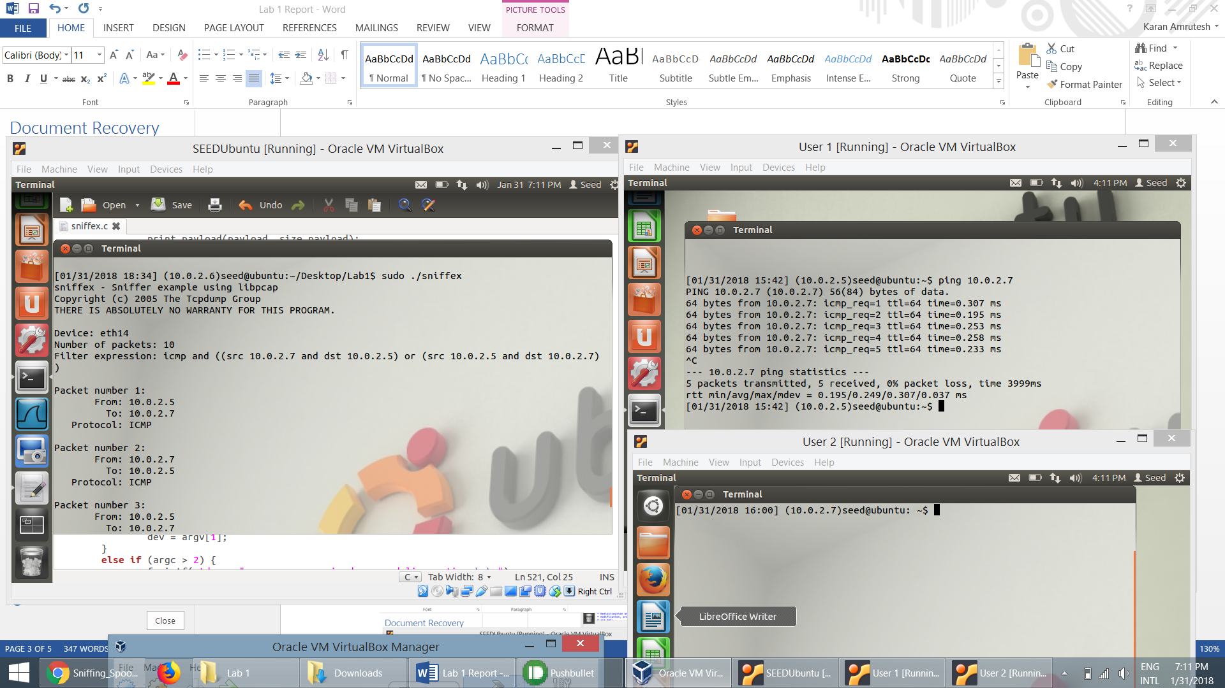

* Capture the TCP packets that have a destination port range from to port 10 - 100.

char filter_exp[] = "tcp dst portrange 10-100";

* In the snapshot below, we can see that when the machine 10.0.2.5 pings 10.0.2.7, nothing happens as the port number is not in the range of 10 and 100. When telnet (which has port number 23) is used, the sniffex program captures the packets as it is in the range.

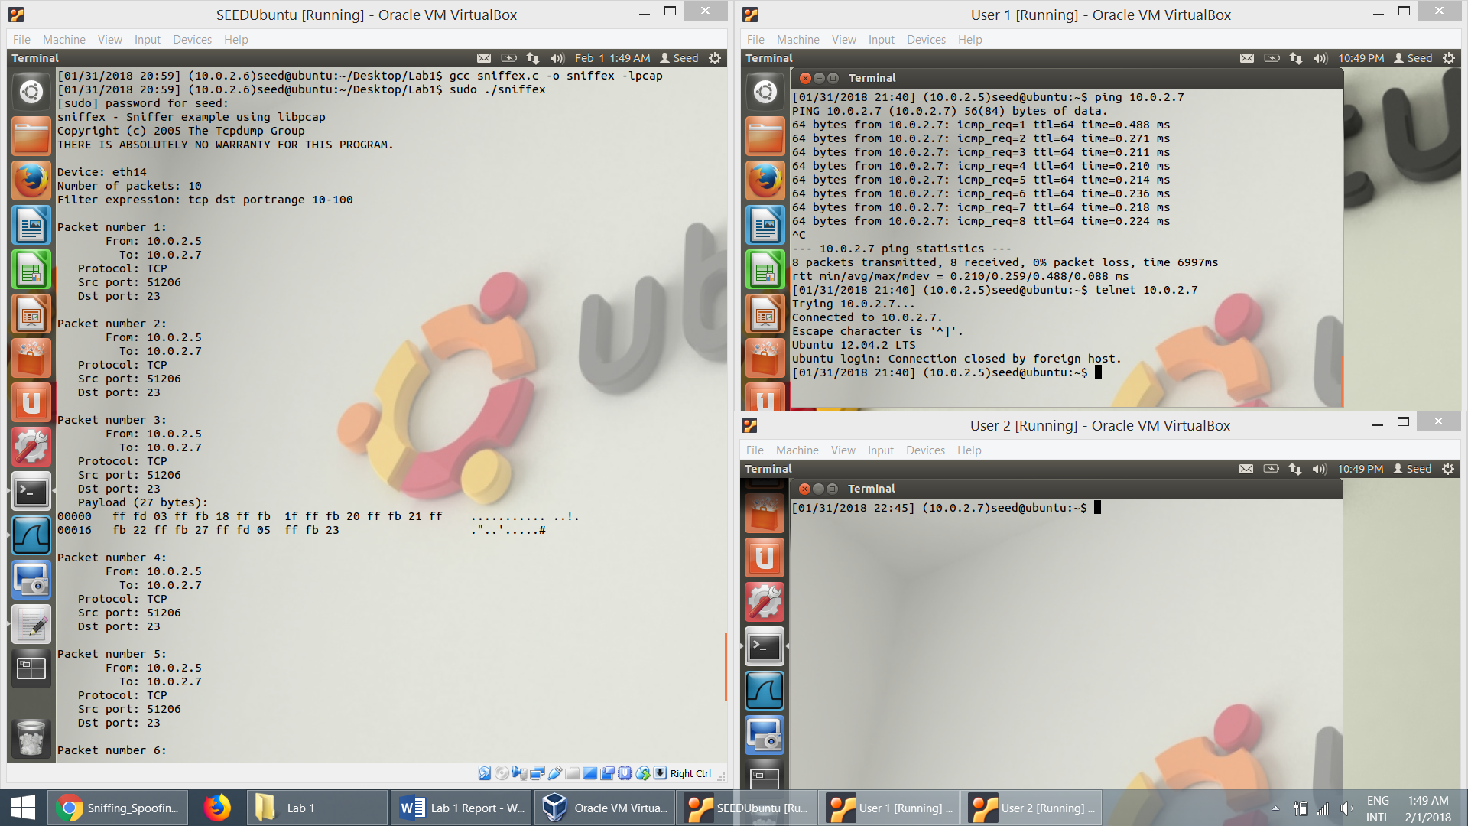

**Task 1.c.** Sniffing Password:

* We set the filter expression to port 23 in order to capture telent packets.
* Also, we set the number of pcakets to -1 so that we can capture all the packets.

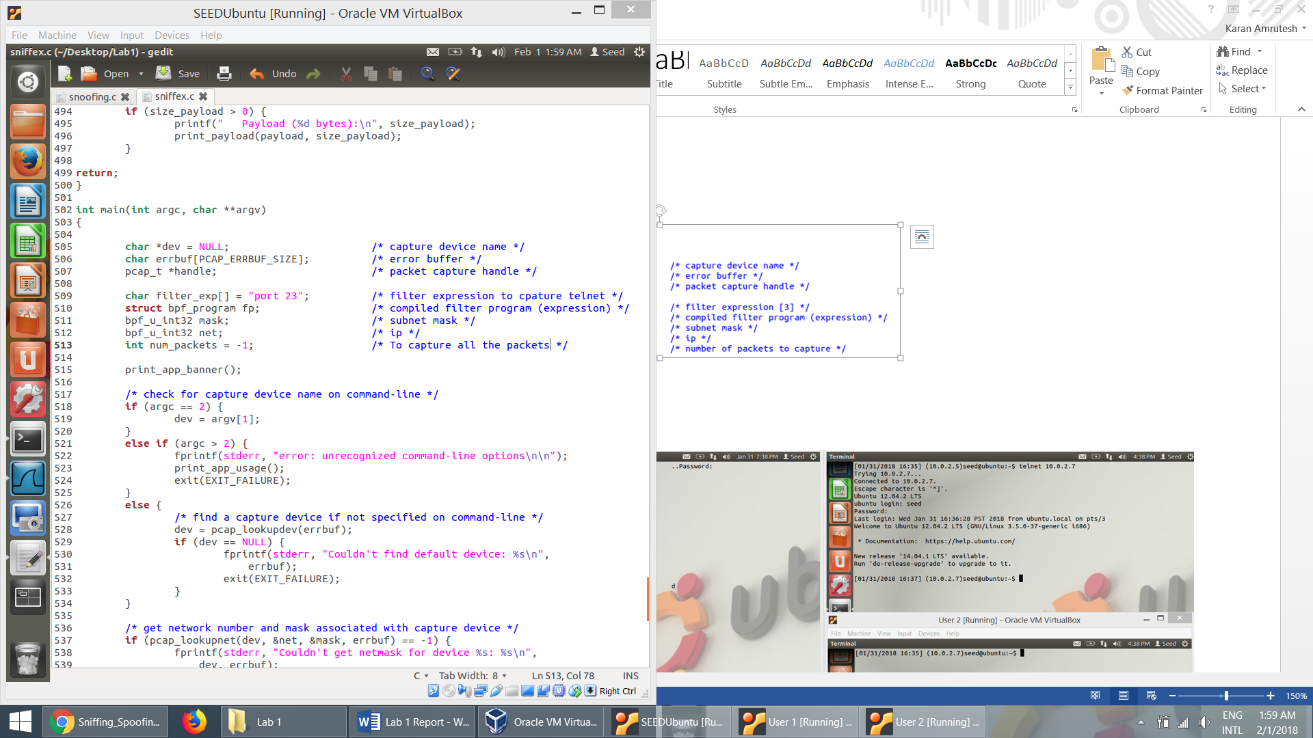

* The user (10.0.2.5) establishes a telnet connection to host (10.0.2.7). The credentials for the host are entered by the user. These credentials are displayed in the terminal runnning the sniffer program.
* The telnet connections run on port 23. So, when we sniff with filter set to 23, the entire telnet traffic is displayed in plaintext in the terminal of sniffer program.

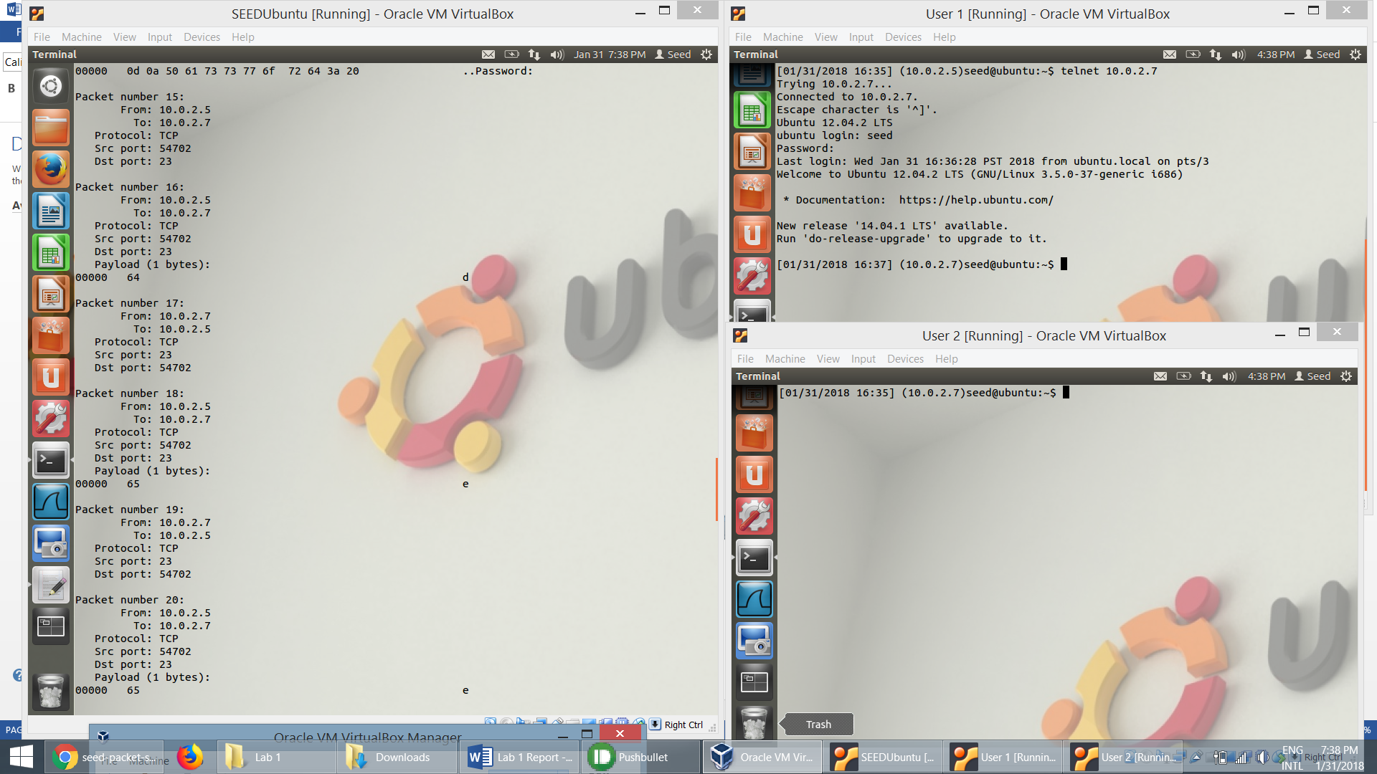

**Task 2. Spoofing:**

**Task 2.a.** Write a spoofing program.

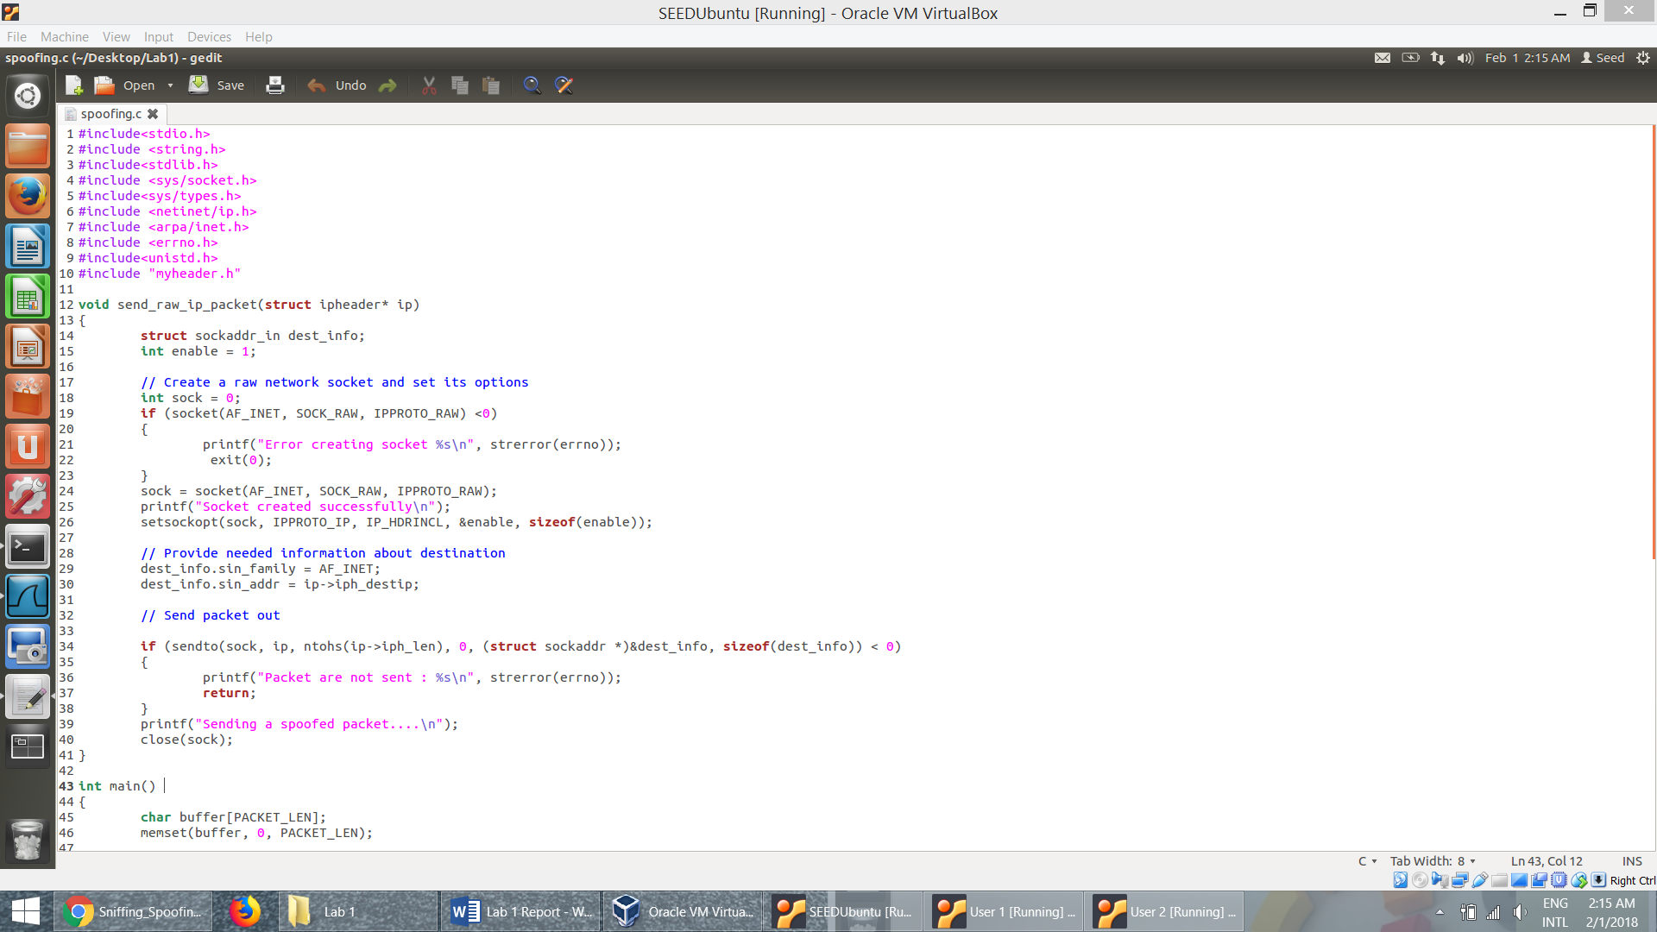

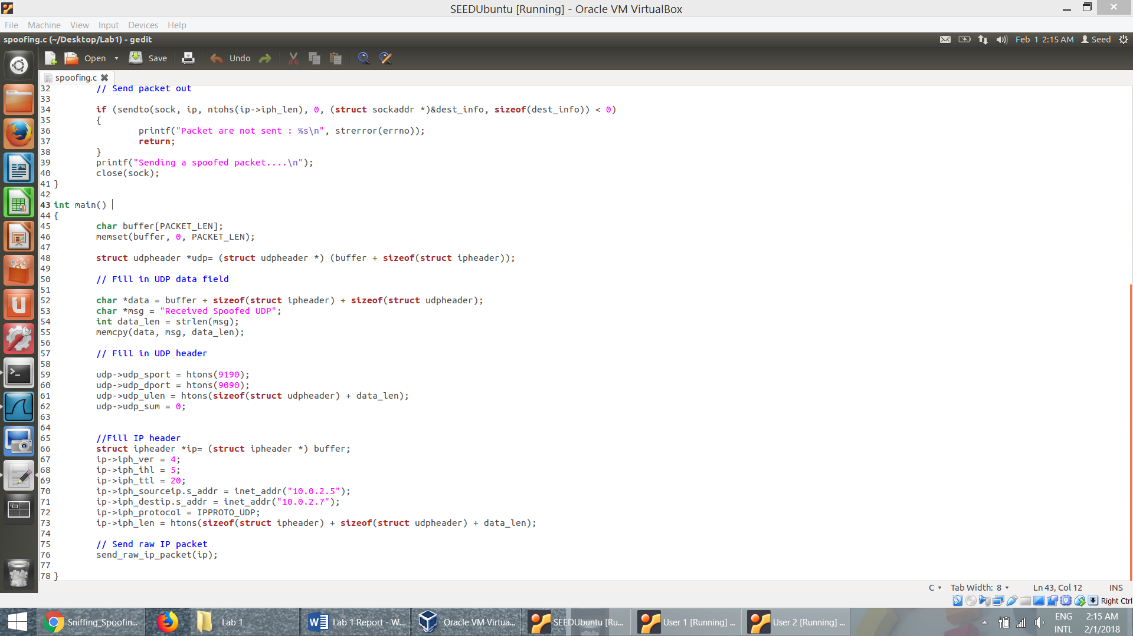

* + The spoofing program running on the machine (10.0.2.6) spoofs UDP packet with a message “Received spoofed UDP” and sends it to the user 2 (10.0.2.7) as though it sent from user 1 (10.0.2.5).
  + The Wireshark packet capture shows this packet from (10.0.2.5) to (10.0.2.7). Whereas the actual transfer is from (10.0.2.6) to (10.0.2.7).
  + Here netcat command (nc –luv 9090) is used to listen to sockets and receive UDP packet here. The source port is 9190 and destination port is 9090.

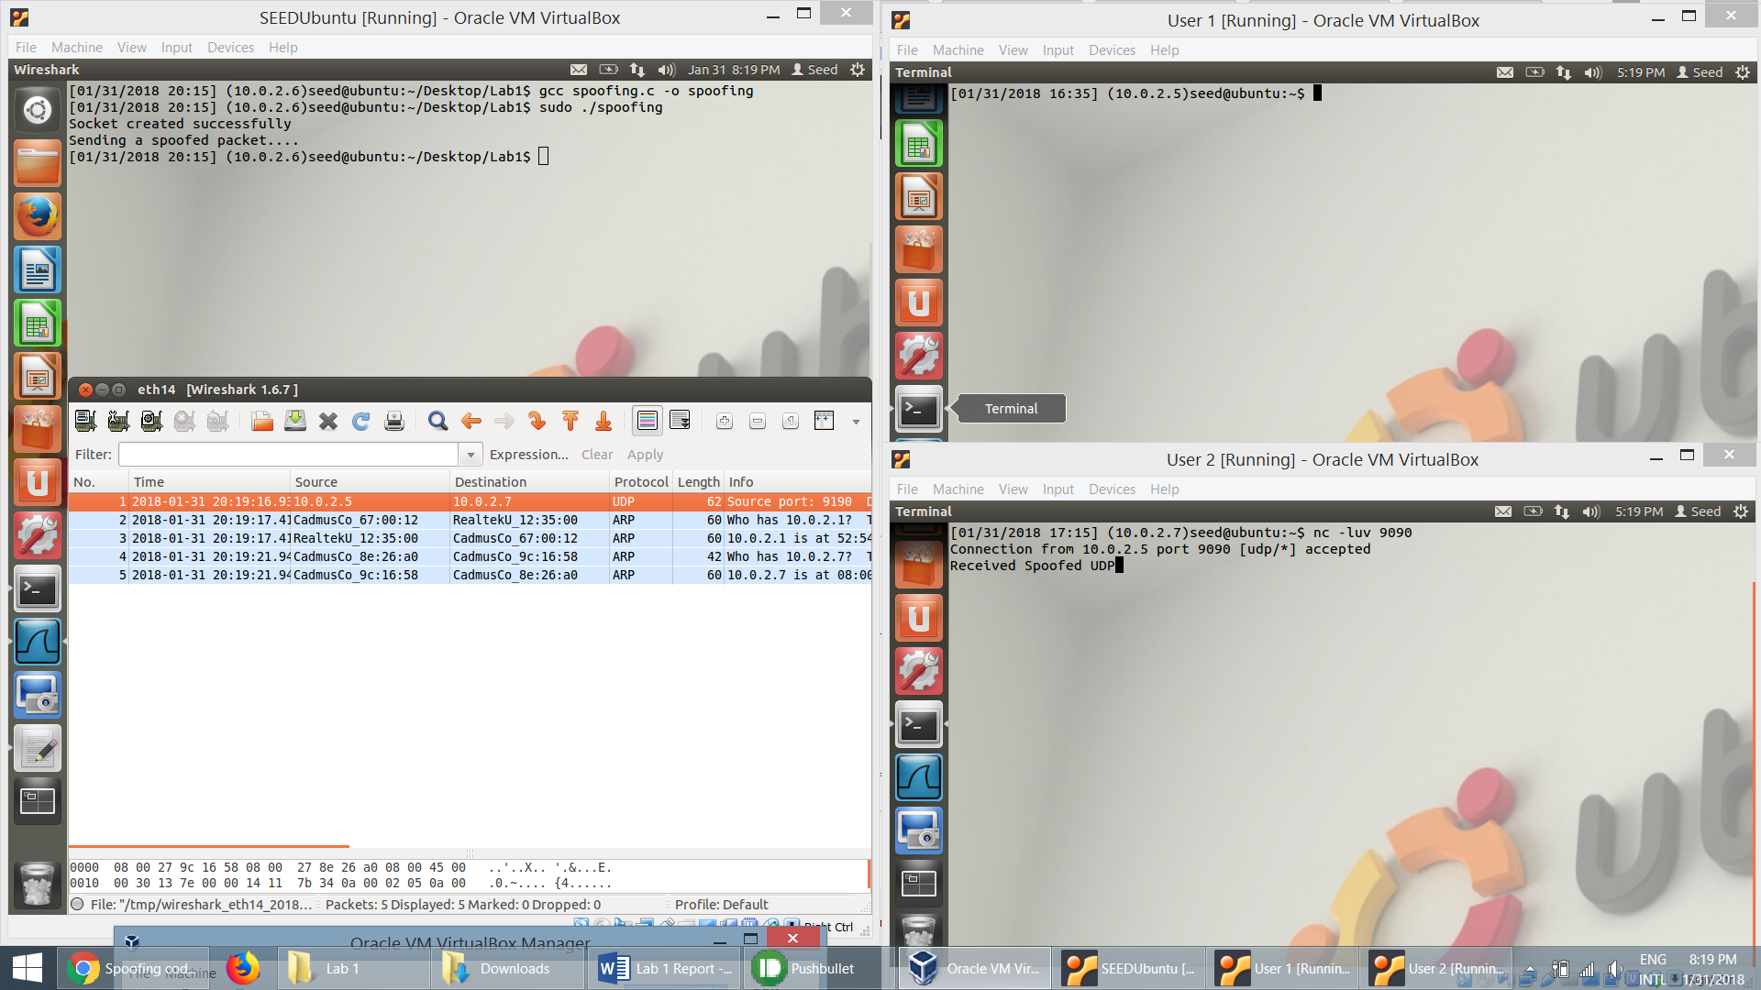

**Task 2.b**: Spoof an ICMP Echo Request.

* The ICMP packet is constructed by specifying the contents in ICMP header and the IP header. The packet is sent using raw socket.

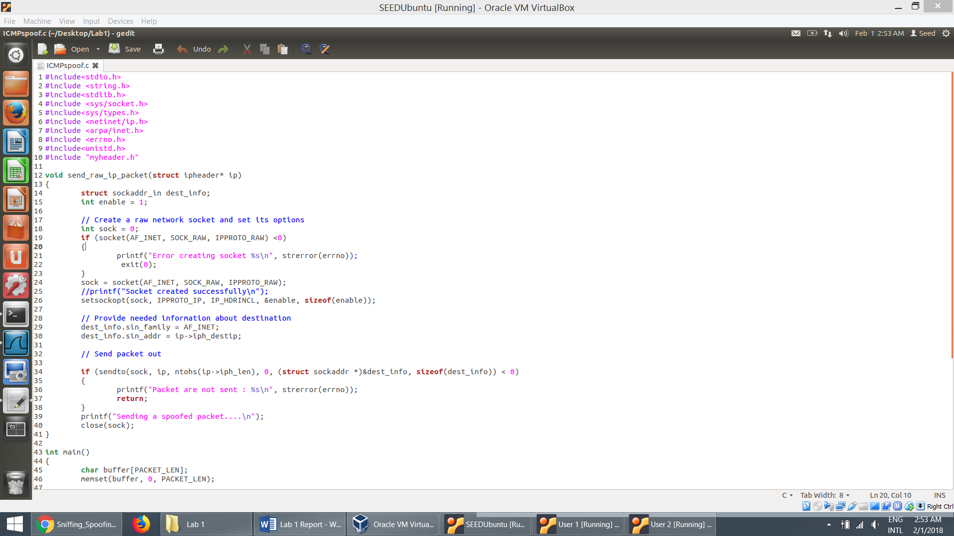

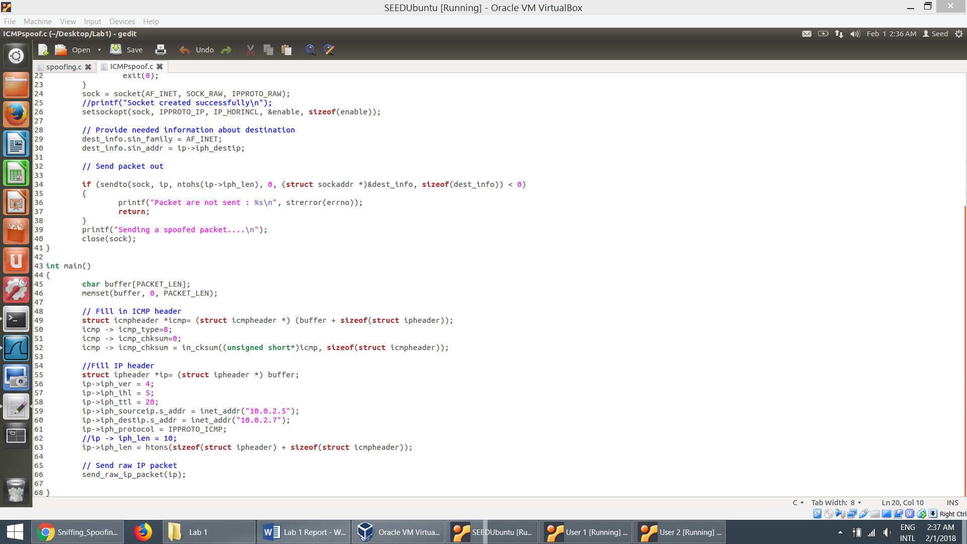

* The snapshot below shows the running of the ICMPspoof program by the host at (10.0.2.6) which creates an ICMP packet and sends it to (10.0.2.7) as though the source of this packet is from (10.0.2.5). The user at (10.0.2.7) recieves the ICMP packet and sneds the reply to 10.0.2.5.
* The wireshark packet capture shows that the user at (10.0.2.7) received an ICMP packet (ping) from another user at (10.0.2.5) and the user at (10.0.2.7) pings back (10.0.2.5).

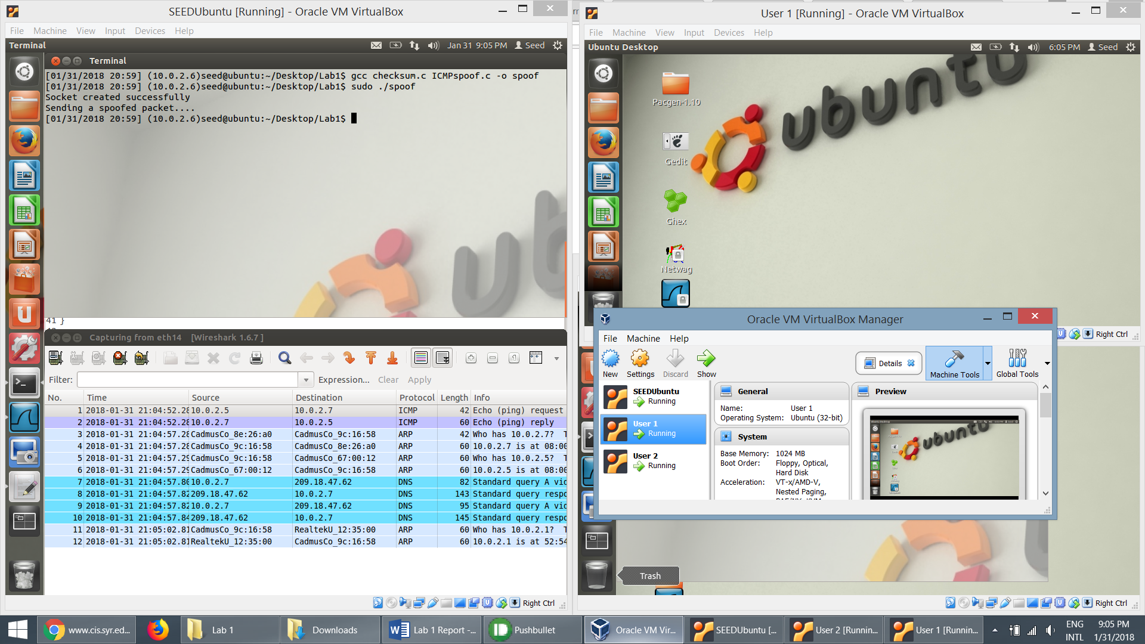

**Questions**

Question 4: Can you set the IP packet length field to an arbitrary value, regardless of how big the actual packet is?

* Here the packet length is set to 10 and is tried to send. As seen in the snapshot, it failes to send
* If we set the length to some random value, the IP packet will not be formed properly. If the packet is too big when it is sent, it will be truncated. The length should be the sum of size of ipheader and the size of icmp header.

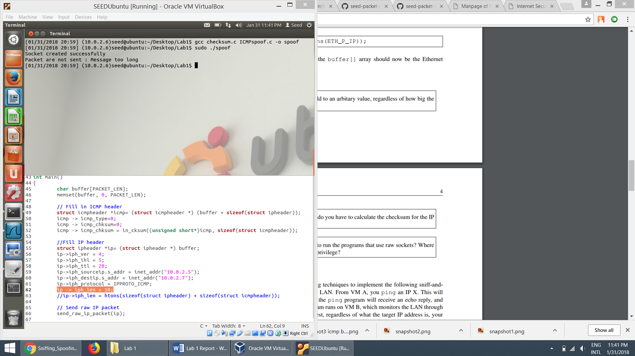

Question 5: Using the raw socket programming, do you have to calculate the checksum for the IP header?

* The checksum for the IP header is calculated by the OS before transmitting the packet over the network, so regardless of the value specified, the OS calculates and then transmits it.

Question 6: Why do you need the root privilege to run the programs that use raw sockets? Where does the program fail if executed without the root privilege?

* When the spoofing program is run as a non-root user, it gives an as it the program needs to access the Network Interface Card in order to send the packet. We can use raw sockets to spoof a packet and set arbitrary values to any field in the packet headers. So in order to perform these tasks, it requires root privileges.
* Snapshot when the spoofing program is run without root privileges:

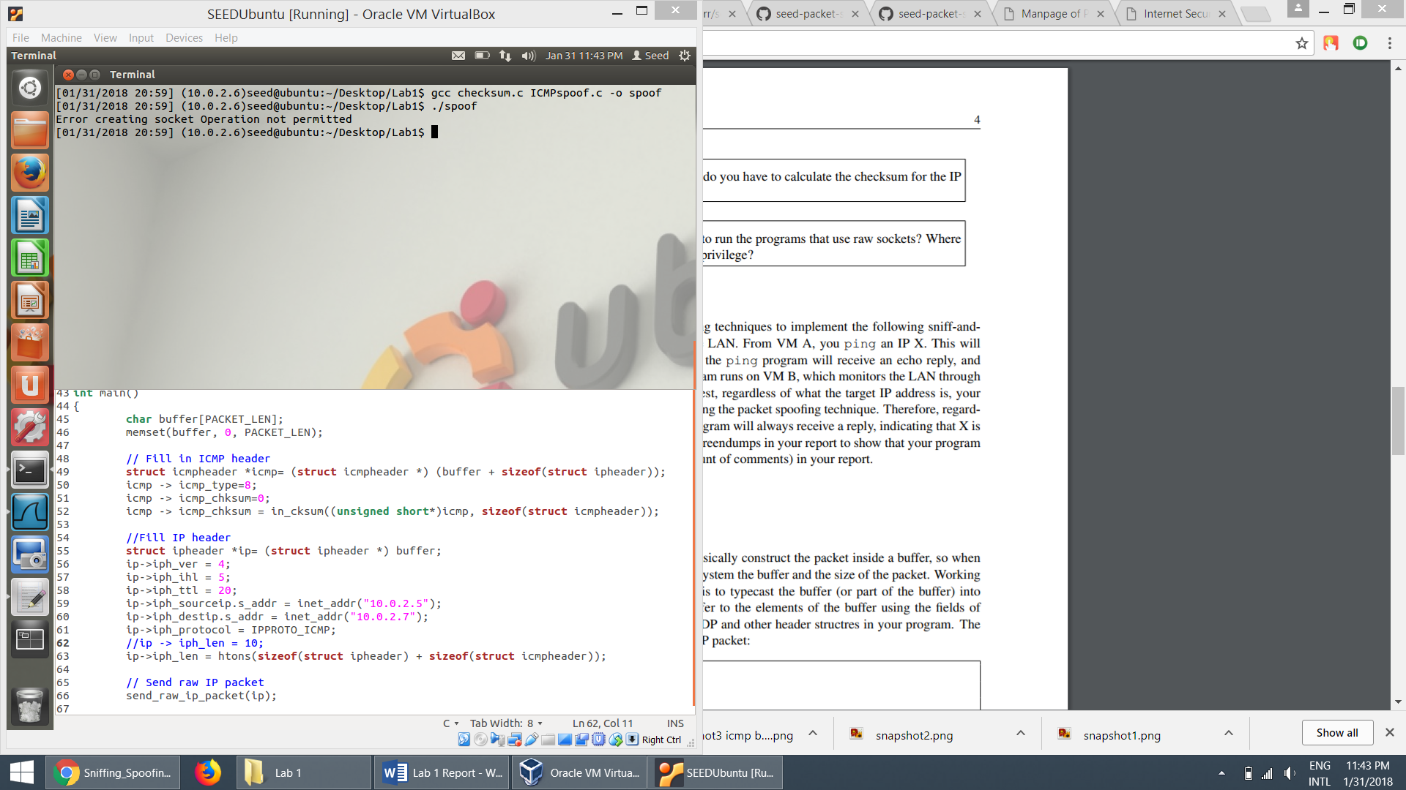

**Task 3: Sniff and then Spoof:**

* + This involves sniffing the request packet and spoofing the reply.

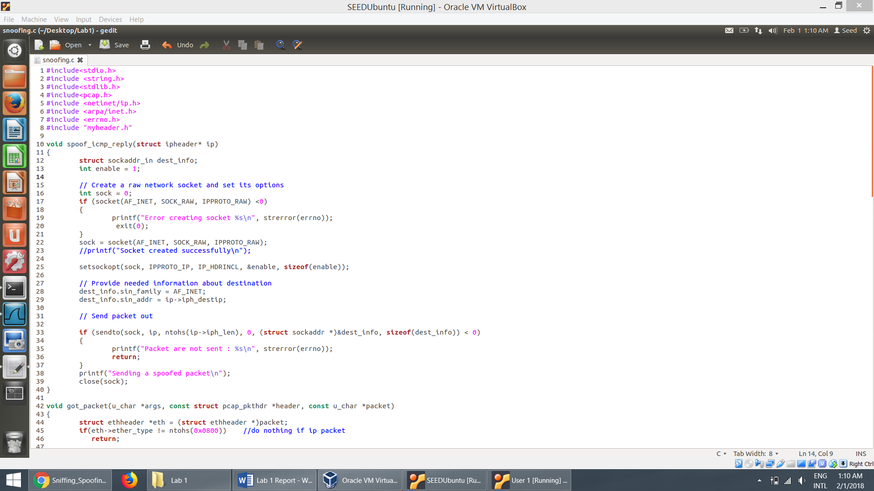

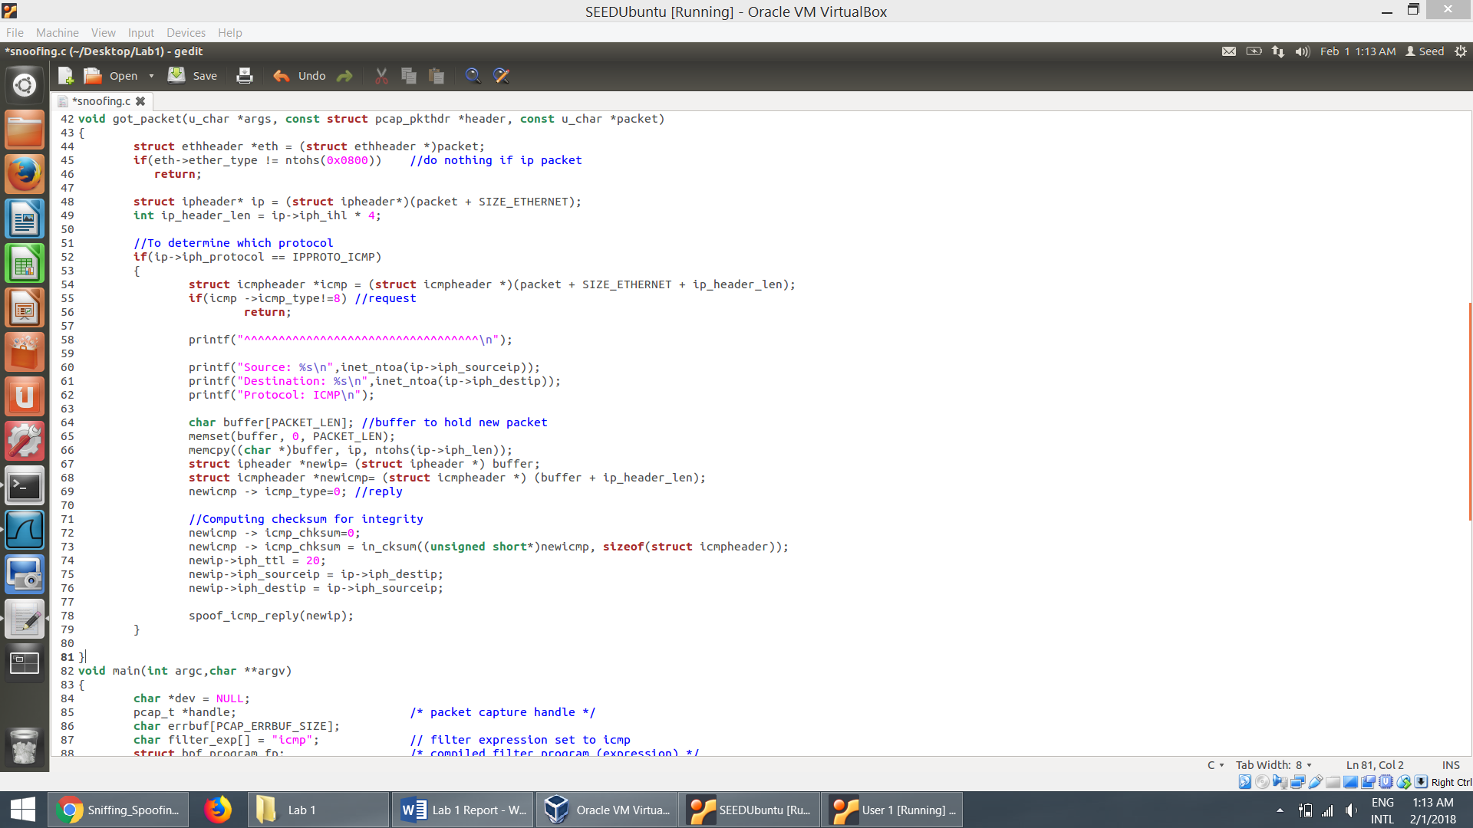

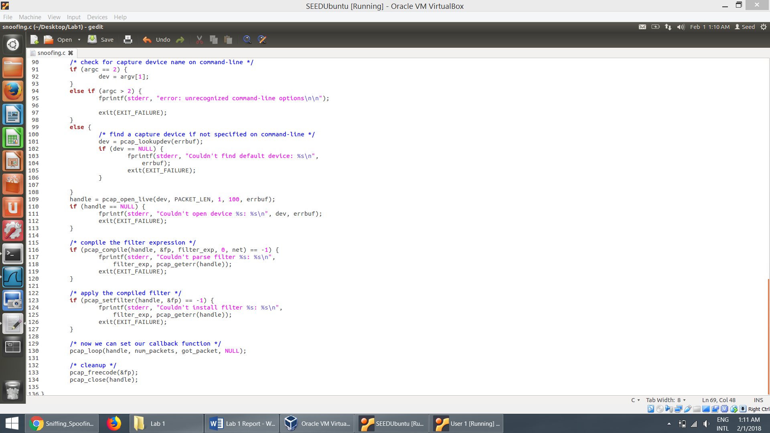

* + The snapshot below the attacker at (10.0.2.6) runs the snoofing program to sniff the ICMP request from the user (10.0.2.5) and spoofs the ICMP reply as if it is originating from 1.1.1.1.
  + When user at (10.0.2.5) pings another user at (1.1.1.1), the attacker receives the ICMP request using pcap while in promiscuous mode. Then, the attacker at (10.0.2.6) spoofs the ICMP reply using raw sockets by replacing destination IP with the source IP (i.e. 10.0.2.5) and source IP with the destination IP (i.e. 1.1.1.1). When the user receives the reply, it seems like the normal reply from (1.1.1.1). Hence, regardless of whether machine (1.1.1.1) is alive or not, the ping program from (10.0.2.5) will always receive a reply, indicating that (1.1.1.1)
  + The Wireshark snapshot shown below is a proof of this.
  + We can also see that once we stop running the snoofing program, there is no reply from (1.1.1.1) to (10.0.2.5) (*last two lines in the Wireshark snapshot*).

